High Level Design Document (HLD)
for
Product Capability Build – PR- DCA EVPN

Copyright © Colt Group
No part of this document may be reproduced or adapted in any form, including photocopying or storing it by electronic means, except as is necessary for the recipient's dealings with Colt, without the written permission of Colt. Any copies made of any part of this document shall include the notice:
© 2022 Colt Technology Services. The Colt name and logos is trademarks. All rights reserved.
No information contained in this document shall be disclosed to any third party without the written permission of Colt.

Contents
1. Introduction 6
1.1. Project Overview / Executive Summary 6
1.2. Assumptions, Risks, Dependencies, Issues & Decisions 7
Inventory Validation:Validate inventory data used by DCA services. 8
2. Delivery Goals & Impact 9
2.1. Summary of project objectives 9
2.2. Project benefits/rationale 9
2.3. Project scope 9
2.3.1. In scope 9
2.3.2. Out of scope 9
3. Solution design 10
3.1. Requirement Traceability 10
3.2. High Level Solution Overview 10
3.3. AS-IS Architecture 12
3.4. Target Architecture 13
3.5. Impacted Systems 13
3.5.1. SFDC – No Impact as Ethernet VPN as an Offering Already Exists 13
3.5.2. CPQ – No Impact Ethernet VPN is Productized Journey 13
3.5.3. Siebel – No Impact as EVPN Network and EVPN Access Products are available today 13
3.5.4. XTRAC – No Impact as Existing workflow for Provisioning EVPN to be followed 13
3.5.5. WebMethods – 14
3.5.6. Kenan – Billing to follow the Global approach 14
3.5.7. IIS – 15
3.5.8. ARM – No Impact as all the DCA EVPN Circuits are migrated from XNG to ARM and are modelled as Standard EVPN Access Circuits with additional parameters for DCA. 15
3.5.9. AMN Cache – No Impact, BAU functionality 15
3.5.10. Impact Engine – No Impact BAU functionality 15
3.5.11. SMARTs – DCA EVPN Circuits are monitoring in SMARTs today. Hence no Impact 15
3.5.12. Skylight – Performance Monitoring to function as BAU as per Global approach for Standard EVPN Access Sites. No Impact 15
3.5.13. OMP – No impact. BAU Functionality 15
3.5.14. Scriptura – No Impact BAU Functionality 15
3.5.15. GCP – No Impact BAU Functionality. 15

List of diagrams
Figure 1 6
Figure 2 6
Figure 3 7
Figure 4 20
Figure 5 21
Figure 6 23

Document information
Version history
Version | Issue Date | Author | Reason for Change
V0.1 | 15/07/2026 | Victor Kakarla | Product Readiness for Ethernet VPN DCA

Contributors
Name | Department | Sections / Chapters
Victor Kakarla | Strategy & Architecture | All

Distribution list
Name | Department
Amit Jain | Businss & Process Analyst
Nakagawa, Yuta | Ethernet VPN DCA Product Management
 | Service Delivery
 | Sales
 | SE
 | Order Entry
 | CSOD
 | NOC
 | Change Management
 | CPQ Dev
 | Premise Master Dev
 | eXplore Dev
 | e-Bonding, CCAPI, CPQAPI, CPQ Map Dev
 | Siebel Dev.
 | XNG/ ARM
 | COL
 | OMP
 | Scriptura
 | GCP/ SAP HANA/ BI
 | SAP ERO Dev
 | Pricing/ MMT
 | Deal Pricing
 | Optical n/w Engg.
 | ITA
 | QAG

Reference documents
Document/Artefact Name | Author
20260227_AsiaSiebelAttributeMapping_MasterList.xlsx | Amit/Geetika/Amar
DCA-EVPN Order List.xlsx | Yuta-San

Introduction

Project Overview / Executive Summary

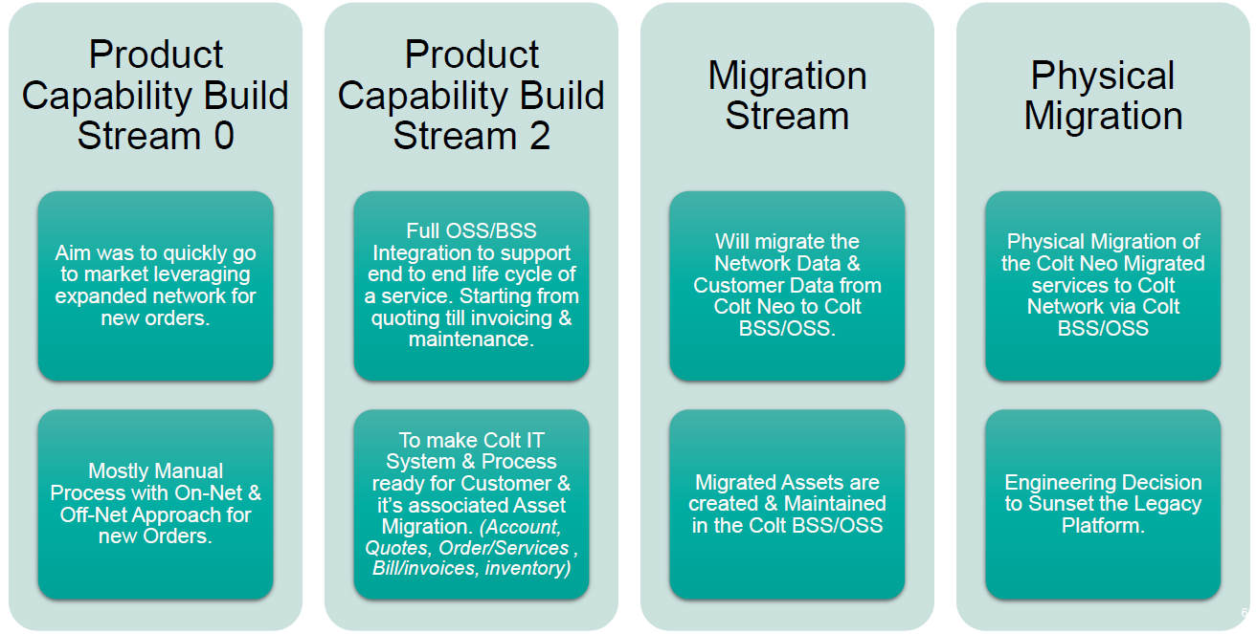
Figure 1

This design document focuses on building the IT capability for Product Capability Build PR
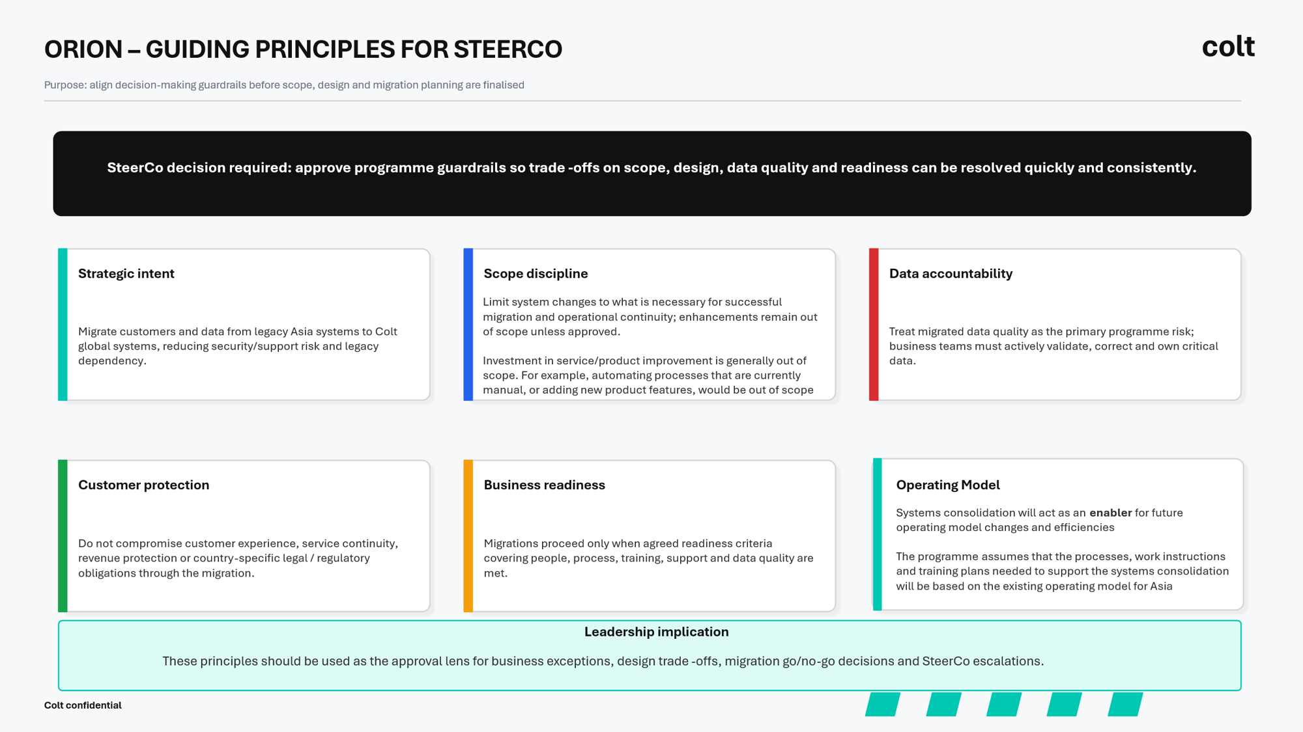
Figure 2
Please find below the overall Product Readiness and Migration plan:

Assumptions, Risks, Dependencies, Issues & Decisions
Identifier | Design Assumption | Owner | Status | Validated with
Assumptions applicable for each requirement is covered under Detailed Design section under each applicable Requirement.

Identifier | Design Decision | Owner | Status | Comments
DD-01 | DCA EVPN as a separate offering will be implemented as part of the ASA Program stream. Currently DCA EVPN is in the priority 2 list | Mitchell/Yuta-san | Closed

Identifier | Design Dependency | Owner |  | Status | Comments
DD-02 | This design has a dependency on the Billing Foundation design to implement the interface from Kenan to IIS for the Asia Invoice Generation. | Sakthi |  | Open
DD-03 | This Design has a dependency on the Billing Foundation Design to pass all of the Asia Invoice specific Order and Billing Configuration from WebMethods to Kenan/IIS and not BRM | Shankar |  | Open
Requirement specific Dependencies are covered under each Requirement under Detailed Design section.

Identifier | Design Issue | Owner | Status | Comments
DI-01 | Provide list of all 89 DCA EVPN sites. | Yuta-san/Amit | Closed
DI-02 | Validate DCA EVPN inventory information in ARM. | Yuta-san | Closed | EVPN Inventory is available in ARM as confirmed during the Workshop
DI-03 | Implement Solution Reference approach for DCA identification. | Amit | Closed | To be covered in STTM mapping
DI-04 | Define formatting rules for DCA configuration information. | Amit | Closed | To be covered in STTM mapping
DI-05 | Validate and document use of Special Instructions field. | Amit | Closed | To be covered in STTM mapping
DI-06 | Prepare migration grouping (EVPN, EVPN+DCA, EVPN+DCA+Additional Routers). | Asia Business | Open | Grouping logic to be provided by Asia Business for Migration
DI-07 | Create operational work instructions for DCA modification handling. | Amit | Open
DI-08 | DCA Monitoring:Confirm current monitoring model and future-state monitoring requirements. | Deepak Laxmi | Closed | DCA EVPN Sites are monitoring in SMARTs
DI-09 | Performance Monitoring: Identify performance monitoring and reporting requirements. | Piyush, Ritesh | Closed | Performance monitoring for DCA EVPN site done in Skylight
DI-10 | Service Monitoring:Identify service monitoring dependencies for DCA sites. | Deepak Laxmi | Closed | Service monitoring same as standard EVPN Site
DI-11 | Inventory Validation:Validate inventory data used by DCA services. | Saurabh/Piyush | Closed | DCA EVPN Sites configured in ARM
DI-12 | Invoice Mapping:Review invoice fields and identify replacement mapping in Global Siebel. | Victor | Closed | Included in Design below
DI-13 | Invoice Sample Collection:Collect sample invoices for all affected products. | Yuta-san | Closed
DI-14 | Billing Mapping:Update WebMethods mappings required for invoicing. | Victor | Closed | Included in Design below
DI-15 | Reporting Impact:Assess GCP reporting impact and duplication risks. | Ritesh | Closed | Asia Siebel Data is flowing into GCP. Going forward data to be sent from Global Siebel for Asia Siebel Order
DI-16 | Operations Readiness :Conduct review with Network Operations and Service Assurance teams. | Muthu | Open
DI – 17 | There are technical limitation with the circuits on Asia Siebel to be monitored on the Skylight (Something to do with Asia Siebel Service ID). Because of this reason, I expect most of traffic reporting item on Asia Siebel is on legacy "Infovista". Ritesh is working on a project to migrate those Asia Siebel circuits on Infovista into Skylight. | Ritesh | Open

Delivery Goals & Impact

Summary of project objectives
High Level objectives of this Design are to cover any changes required to successfully migrate DCA EVPN Sites from Asia stack to Global stack as Standard EVPN Sites and support end to end quoting, ordering, provisioning, Billing, Inventory, Fault Monitoring, Proactive Monitoring and Performance Reporting via the Global Stack.

Project benefits/rationale
Colt would have a single IT stack for EU and Asia and the Asia IT Stack can be decommissioned which would reduce the Opex and better security.

Project scope

In scope

- New Orders / Colt Asia Migrated Services for Existing Colt Customers/ Migrated Colt Neo Customers–
  - Fulfilment
Device Platform | New Order | MOD-Tech/ MOD-Com | Cease
Global Stack | Yes | Yes | Yes
  - Assurance
Device Platform | Device Monitoring | Service Monitoring | Device Auto Ticketing | Service Auto Ticketing | Reactive Ticketing | Performance Reporting
Global Stack | Yes | Yes | Yes | Yes | Yes | Yes
  - Billing
Device Platform | Billing
Global Stack | Yes

Out of scope
- E2E implementation of DCA EVPN as standard offering in Global stack. It will be implemented in the ASA Program stream
- Kenan to IIS Interface will be designed as part of the Billing Foundation Design.
- Siebel to Kenan via wM changes to be covered in Billing Foundation Design for all Products.

Solution design

Requirement Traceability
Requirement Ref. | Azure Ref. | IT Dev impact under Wave Phase 1/ PR1 Stream | Dependency | Process Impact | Product Agnostic Requirement

High Level Solution Overview

We will be migrating DCA EVPN as Standard EVPN Sites on to the global stack. This design covers change that may be required for Standard EVPN Sites to accommodate any changes required for DCA EVPN.

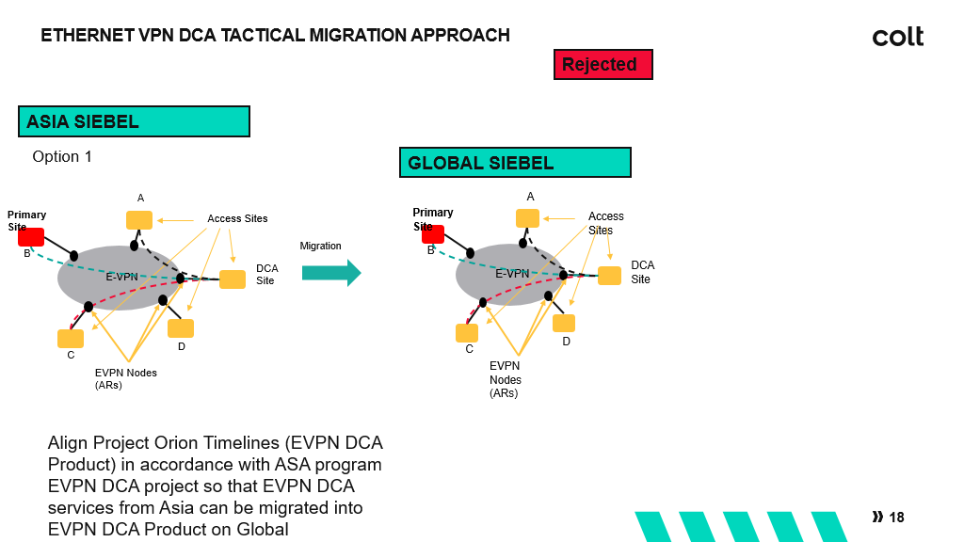

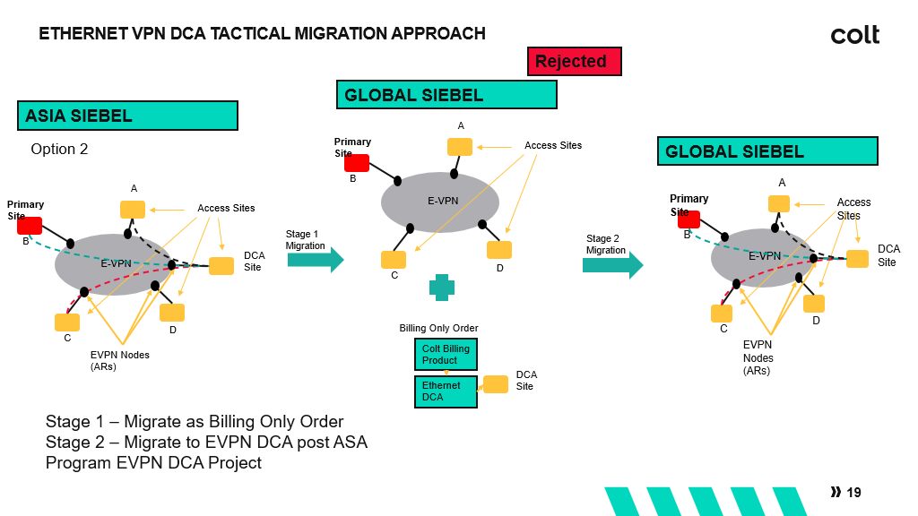

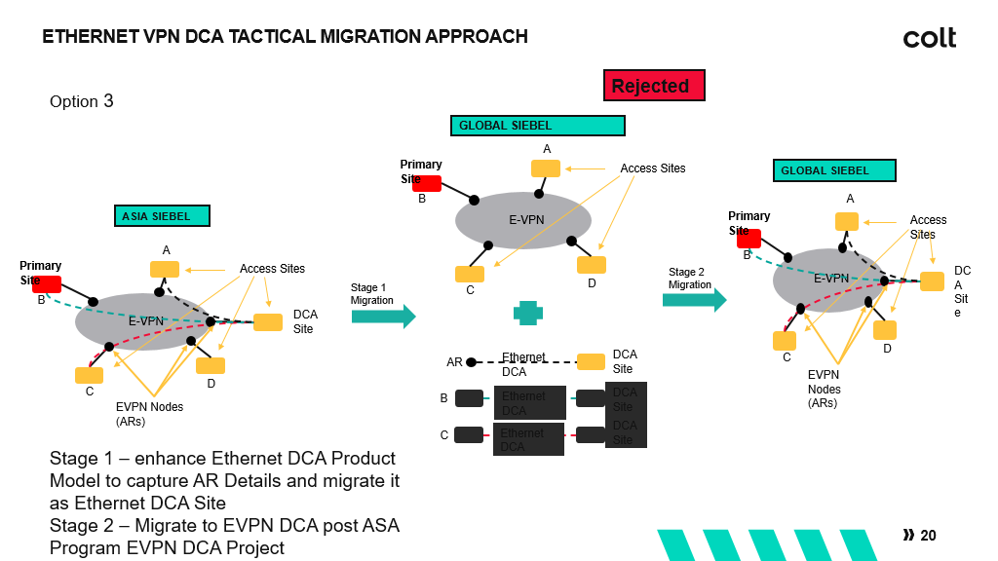

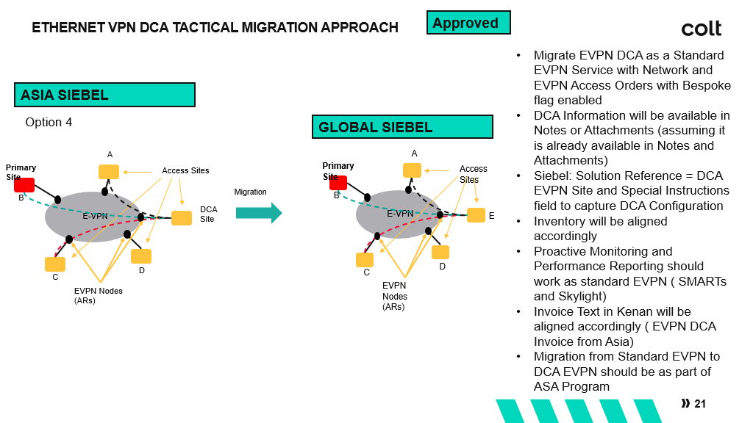

AS-IS Architecture

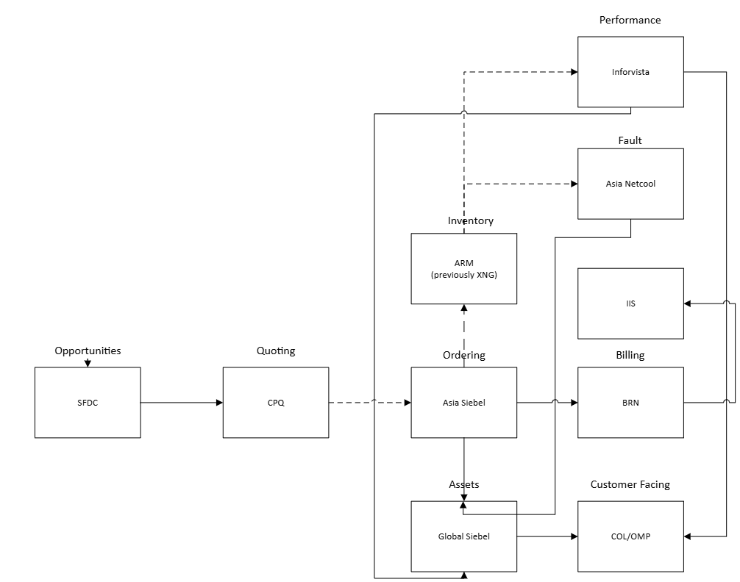

Target Architecture

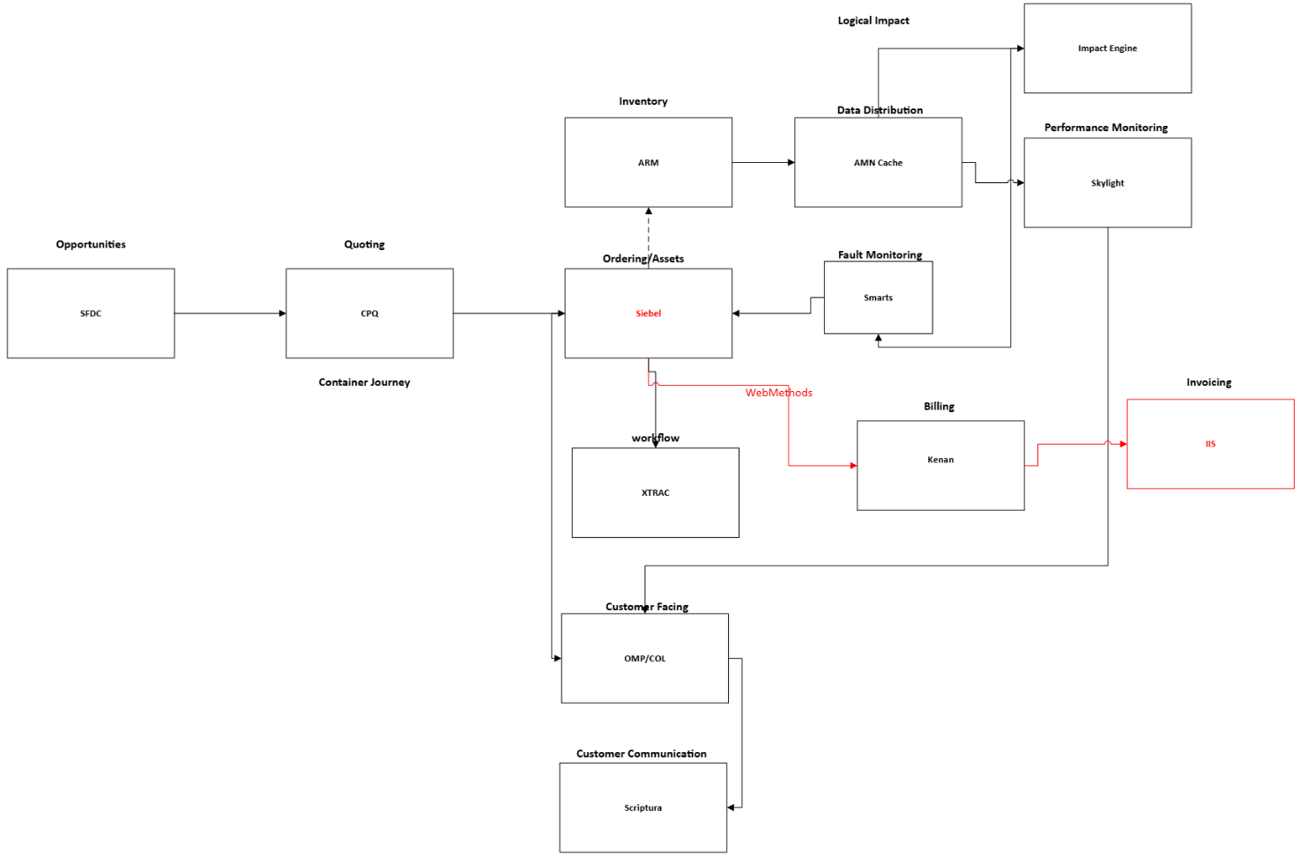

Impacted Systems

SFDC – No Impact as Ethernet VPN as an Offering Already Exists

CPQ – No Impact Ethernet VPN is Productized Journey

Siebel – No Impact as EVPN Network and EVPN Access Products are available today

To be populated during the migration.
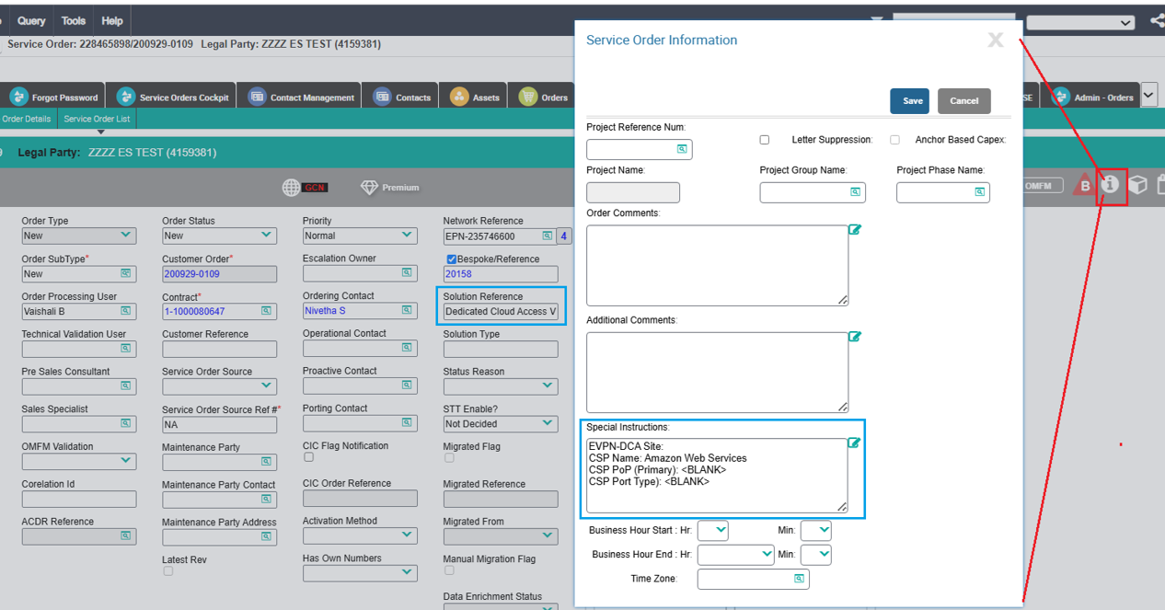

.

XTRAC – No Impact as Existing workflow for Provisioning EVPN Network & EVPN Access to be followed

CEOS – No Impact, BAU Functionality.

WebMethods –

for Contracting Countries = Japan, Hong Kong & Singapore, Seibel Attribute & Billing configuration to be sent to Kenan/IIS for Invoicing (to be covered in Foundation billing Design for all Products)

Additional parameter – Solution Reference to be sent to Kenan/IIS to be printed in the Invoice.

Kenan – Billing to follow the Global approach

IIS –

Kenan to pass the Attribute configuration & billing to IIS for Invoices to be generated in Asia Format (to be covered in Foundation Billing Design)

Additional parameter to be printed on the Invoice as Solution Reference

Sample invoice

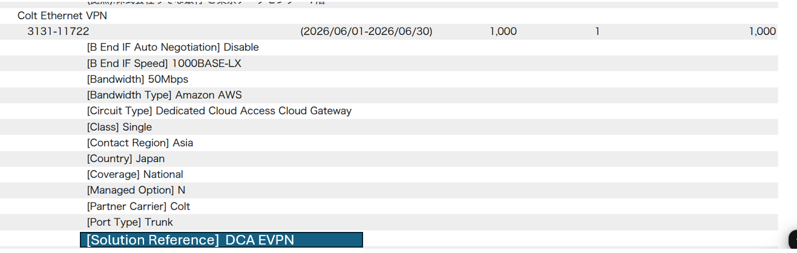

ARM – No Impact as all the DCA EVPN Circuits are migrated from XNG to ARM and are modelled as Standard EVPN Access Circuits with additional parameters for DCA.

AMN Cache – No Impact, BAU functionality

Impact Engine – No Impact BAU functionality

SMARTs – DCA EVPN Circuits are monitoring in SMARTs today. Hence no Impact

Skylight – Performance Monitoring function as BAU as per Global approach for Standard EVPN Access Sites. No Impact

OMP – No impact. BAU Functionality

Scriptura – No Impact BAU Functionality

GCP – No Impact BAU Functionality.

